Comprehensive Time Series Analysis of
RUSSIAN MILITARY LOSSES

School of Computer Science Engineering and Technology


Bennett University
Greater Noida, Uttar Pradesh

Submitted by- Submitted to-
Ayush Maurya Dr. Mala Saraswat [E22CSEU1586]

INTRODUCTION
The ongoing Russia-Ukraine conflict, beginning in February 2022, has resulted in significant military losses for Russia, encompassing both personnel and a wide range of equipment, from tanks and armored vehicles to drones and artillery systems. Understanding the scale, patterns, and future trajectory of these losses is critical for defense analysts, policymakers, and researchers seeking to assess the conflict’s intensity, Russia’s resource depletion, and strategic implications. This report leverages the russia_war_losses dataset, sourced from Kaggle’s 2022 Ukraine-Russian War dataset, to conduct a detailed time series analysis of Russian military losses from February 25, 2022, to April 27, 2025.
The analysis pursues two primary objectives:
- Exploratory Analysis: Utilize visualizations to uncover temporal trends, proportional contributions, and variability in equipment (e.g., tanks, drones, APCs) and personnel losses, providing insights into conflict dynamics and operational priorities.
- Forecasting: Predict daily drone (d_drone) and personnel (d_personnel) losses for the next 30 days (April 28–May 27, 2025) using seven time series models—ARIMA, SARIMA, Auto-ARIMA, Prophet, LSTM, XGBoost, and VAR—to evaluate their accuracy and inform strategic planning.

OBJECTIVES
These objectives address key questions:
- What are the dominant loss categories, and how do they evolve over time?
- Which models best predict future losses, and what do these forecasts reveal about the conflict’s trajectory?
By combining exploratory visualizations with advanced forecasting, this report aims to deliver actionable insights into Russia’s military attrition, highlighting both historical patterns and future expectations.

DATA and PREPROCESSING

Dataset Overview
The russia_war_losses dataset is derived from two CSV files: russia_losses_personnel.csv and russia_losses_equipment.csv, merged on date and day to form a unified DataFrame with date as the datetime index. Spanning February 25, 2022, to April 27, 2025 (1159 days), the dataset records cumulative losses for personnel and 16 equipment categories. Key columns include:
- Personnel: personnel (cumulative, e.g., 948640 on 2025-04-27), personnel* (indicates “about” for approximate counts), POW (prisoners of war, often NaN in later dates).
- Equipment: Cumulative counts for aircraft, helicopter, tank, APC, field artillery, MRL, military auto, fuel tank, drone, naval ship, anti-aircraft warfare, special equipment, mobile SRBM system, vehicles and fuel tanks, cruise missiles, submarines.
- Derived Daily Losses: d_drone, d_personnel, d_tank, etc., computed by differencing cumulative columns (e.g., russia_war_losses["d_drone"] = russia_war_losses["drone"].diff()).
- Other: greatest losses direction (mostly NaN in later dates).
The dataset, likely sourced from open-source intelligence or Ukrainian military reports, provides a comprehensive record of losses but has gaps (e.g., NaN in military auto after mid-conflict), requiring careful preprocessing.

Preprocessing Steps
To prepare the data for analysis and modeling, several steps were applied:
- Date Conversion: Converted date to datetime using pd.to_datetime with infer_datetime_format=True and dayfirst=True, ensuring chronological order.
- Merging and Indexing: Merged personnel and equipment datasets on date and day using an inner join, setting date as the index.
- Daily Losses: Computed daily increments for all relevant columns (e.g., d_drone, d_personnel) via differencing to capture day-to-day changes.
- Temporal Features: Added year, month, and week columns (e.g., russia_war_losses["year"] = russia_war_losses.index.year) for temporal analysis and visualization.
- Missing Values: Dropped NaN values for specific analyses (e.g., latest_data.dropna() for the pie chart) to ensure data integrity.
- Stationarity: Applied first differencing to d_drone and d_personnel for ARIMA, SARIMA, and VAR models, confirmed by Augmented Dickey-Fuller (ADF) tests (p-value < 0.05 post-differencing).
- Scaling: Normalized d_drone and d_personnel to [0, 1] using MinMaxScaler for LSTM to stabilize neural network training.
- Feature Engineering:
  - Created lagged variables (lag_1 to lag_7) for XGBoost to capture temporal dependencies.
  - Added temporal features (day of week, month) for XGBoost to model seasonality.
  - Clipped outliers at 1st and 99th percentiles for VAR to reduce the impact of extreme values.
- Aggregation: Binned data into weekly periods for the 2025 losses table using pd.cut with week-ending dates (e.g., January 5, 2025).
These steps ensured the dataset was clean, stationary, and enriched with features for both visualization and modeling, though gaps in certain columns limited their use in some analyses.

EXPLORATORY DATA ANALYSIS and VISUALIZATIONS
Visualizations are central to understanding the scale and patterns of Russian losses, with each plot offering unique insights into equipment and personnel attrition.

Cumulative Losses (Line Plot)
This line plot tracks cumulative losses for tanks, aircraft, APCs, drones, field artillery, vehicles/fuel tanks, and personnel from 2022 to 2025. By April 27, 2025, losses include 10719 tanks, 22325 APCs, 34011 drones, 27007 field artillery units, 46187 vehicles/fuel tanks, and 948640 personnel. The steep rise in personnel losses reflects the human toll, while tanks and APCs indicate heavy ground combat. Drones show a steady increase, underscoring their frequent deployment. The consistent upward trajectories across categories suggest unrelenting attrition, with no signs of slowdown.
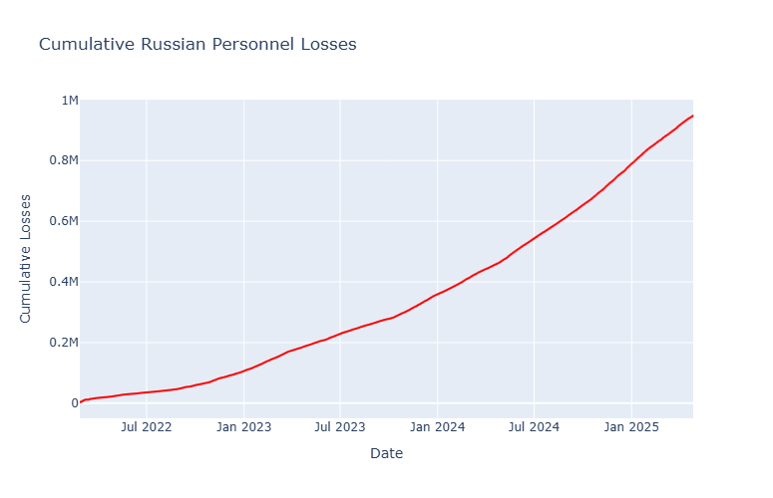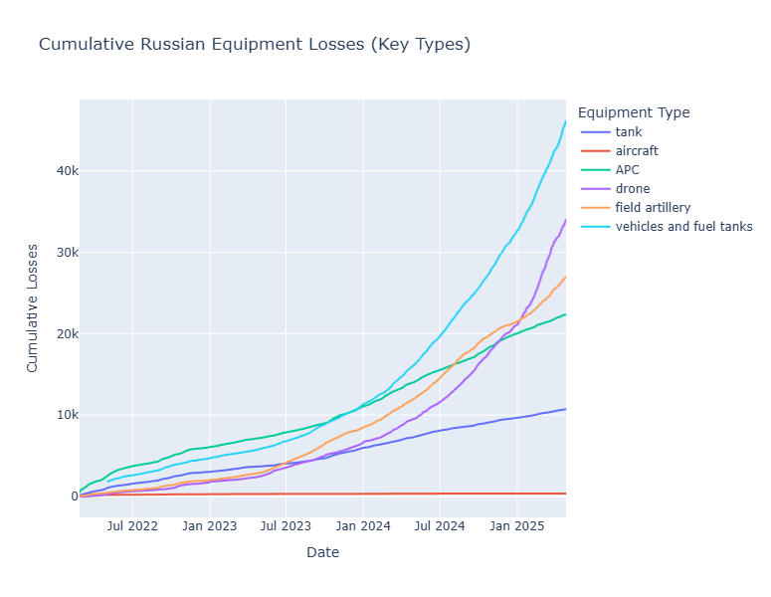
Figure 1: Cumulative Russian Personnel Losses Figure 2: Cumulative Russian Equipment Losses

Daily Losses (Line Plot, Stacked Bar)
The stacked bar chart visualizes daily losses (d_tank, d_aircraft, d_APC, d_drone, d_field artillery, d_vehicles and fuel tanks, d_personnel). Personnel losses fluctuate widely, ranging from 700 to over 1600 daily, with notable spikes in early 2025 (e.g., in February) linked to major offensives. Drone losses are more stable, averaging 100–200 daily, with occasional peaks (50). Tanks and APCs show bursts of 5–20 losses, correlating with ground operations. The stacked format highlights personnel’s overwhelming contribution and drones’ consistent presence, with clusters of high-loss days in 2025 signaling intense fighting.
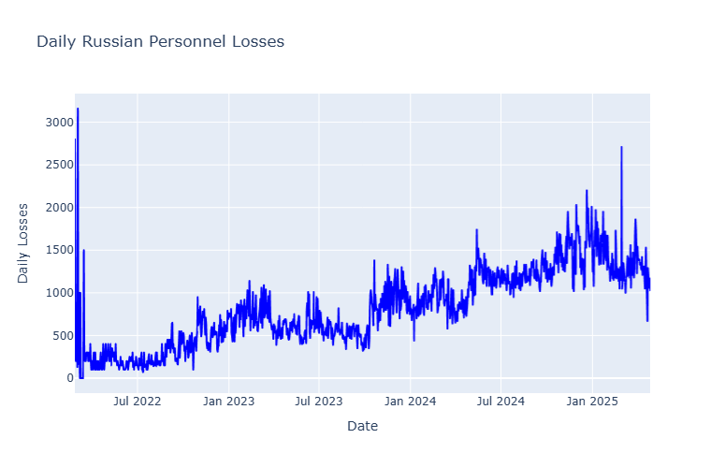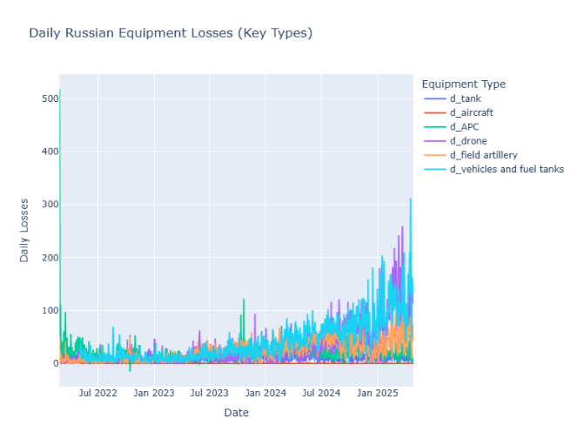
Figure 3: Daily Russian Personnel Losses Figure 4: Daily Russian Equipment Losses
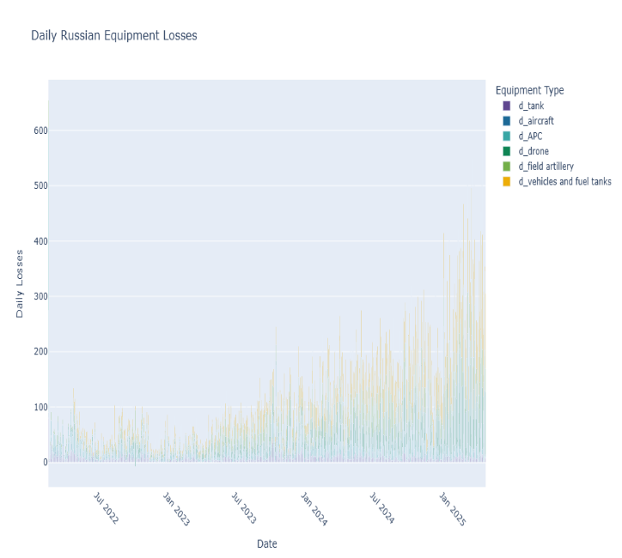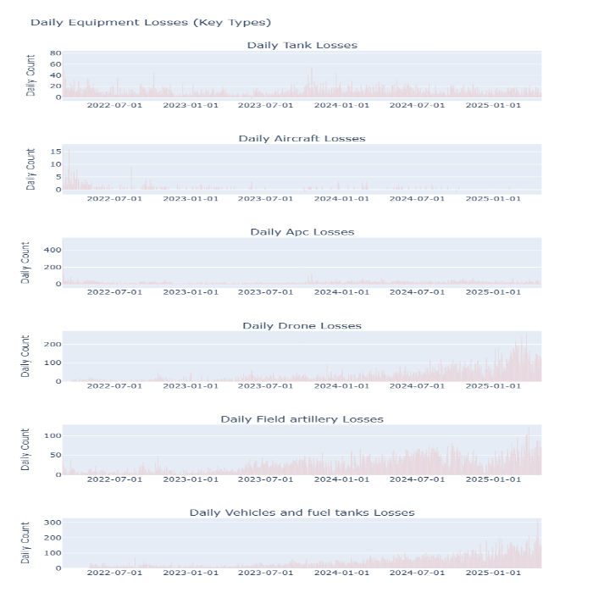
Figure 5: Daily Russian Equipment Losses (Stacked Bar) Figure 6: Sub-Plots of Daily Equipment Losses

Daily Losses vs Day of Conflict (Scatter Plot)
"Daily Personnel Losses vs. Day of Conflict" scatter plot shows the number of daily personnel losses that Russia encountered because of the Russia-Ukraine war. The green markers indicate, and the daily personnel losses of Russian forces are the data that the green markers display. These losses have changed a lot and happen sporadically at various points, some of which have a probable connection to massive battles or an escalation of the war. Day of Conflict has its range from the moment the war started in February 2022 and to the present day. The graphic clearly shows the situation where repeated military losses lead to the worsening of the war and are indicative of the level of violent confrontation. More deaths may result from those days which are most likely to be the days of key dramatic events such as offensives, counterattacks, or strategic shifts. By detecting these high points, we can analyse the war's dynamics and see the turning points easily.
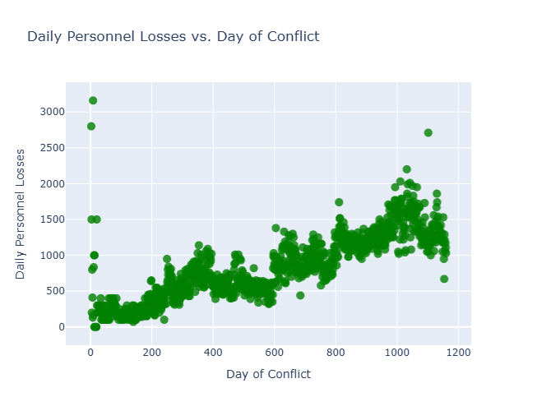
Figure 7: Daily Losses vs Day of Conflict

Proportion of Total Losses (Pie Chart)
As of April 27, 2025, the pie chart shows personnel losses dominating at 70–80% of total losses (equipment + personnel), followed by field artillery (27007 units), vehicles/fuel tanks (_{46187), and drones (}34011). Tanks (_{10719) and APCs (}22325) contribute smaller shares due to their lower counts relative to personnel. Aircraft (370) and naval ships (28) are minor, reflecting their limited numbers. This distribution emphasizes the conflict’s human cost and the strategic importance of artillery and drones in sustained operations.
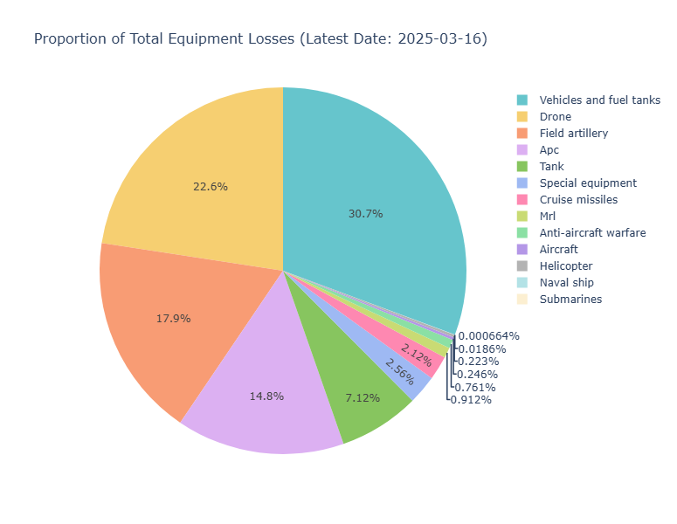
Figure 8: Proportion of Total Equipment Losses

Weekly Losses Table (2025)
This table aggregates daily losses into weekly sums for 2025, covering all equipment types. Drones lose ~400–1000 weekly, tanks ~20–90, and field artillery ~200–400. The table’s granular view identifies February 2025 as a critical period, with synchronized spikes across categories suggesting large-scale engagements.
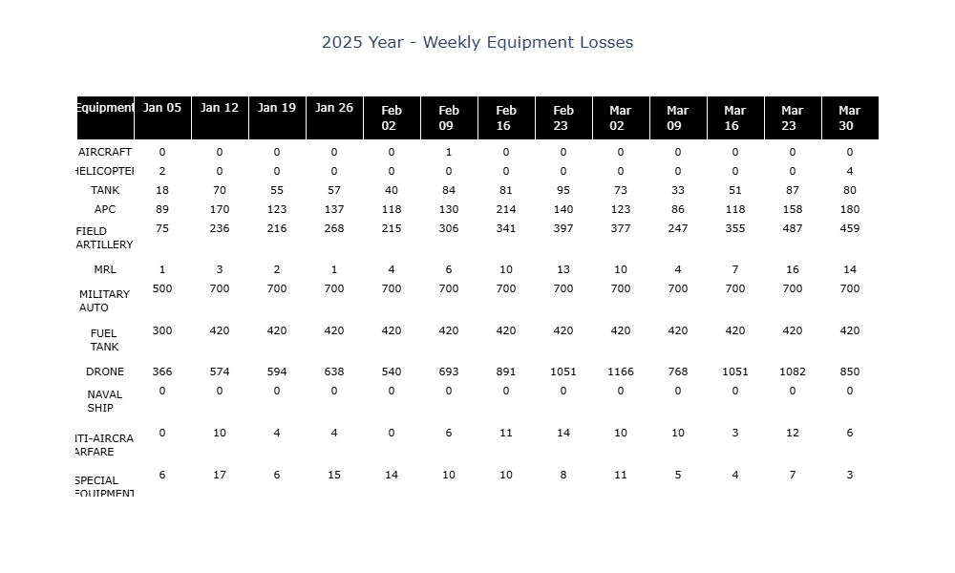
Figure 9: Weekly Equipment Losses

Treemap of Losses
The treemap organizes daily losses hierarchically by year, month, and type. Personnel losses dominate across 2022–2025, with 2025’s January–April period showing elevated values (e.g., ~200,000 total). Drones and field artillery are prominent in 2025, reflecting their high attrition rates. The treemap’s structure reveals temporal trends, with 2025 emerging as a high-loss year, particularly for personnel and drones, providing a clear visual of loss distribution over time.
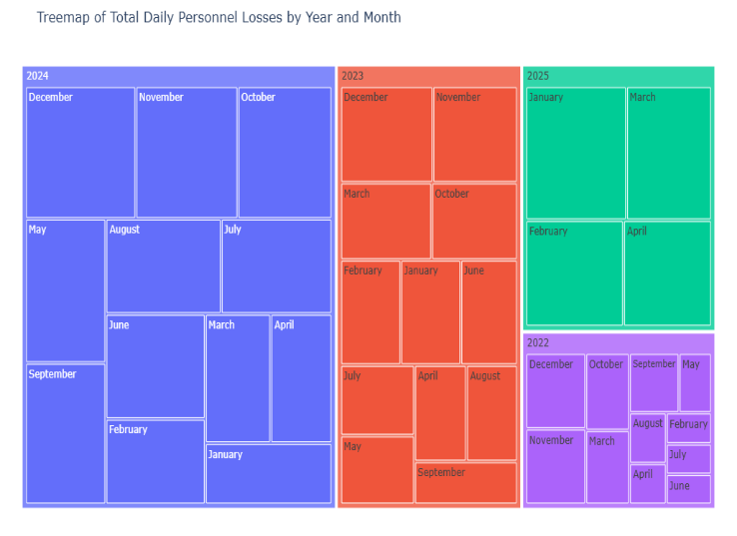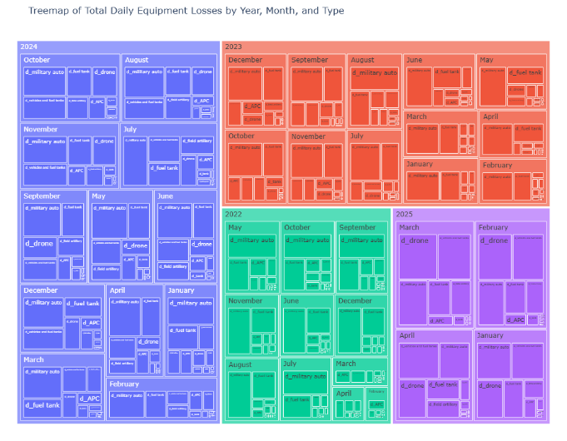
Figure 10: Treemap of Daily Personnel Losses and Equipment Losses

Distribution of Daily Losses (Box Plot)
The box plot illustrates the variability of daily losses. Personnel losses have a median of ~500 but range widely, with outliers exceeding 1000, driven by episodic battles. Drones are steadier, with a median of ~15 and outliers up to ~290, indicating consistent but occasionally spiked losses. Tanks and APCs have medians of ~5–10, with fewer extreme outliers. This variability informs model selection, favoring robust methods like Auto-ARIMA for personnel’s volatility and simpler models for drones’ stability.
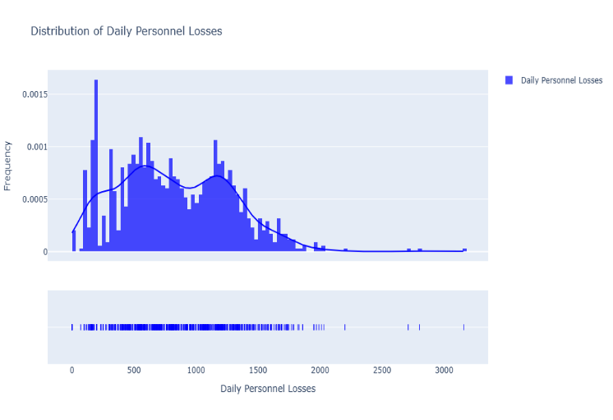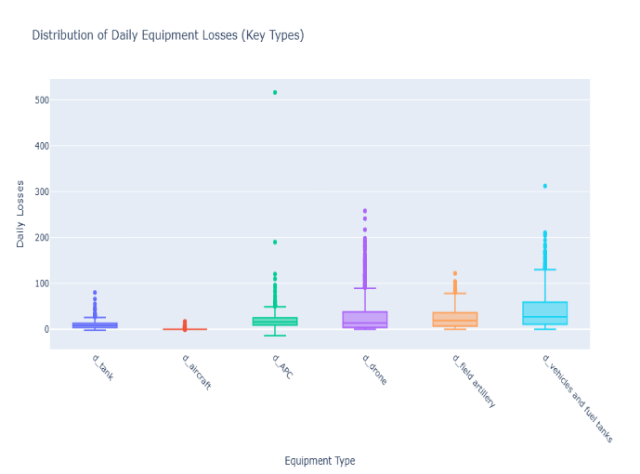
Figure 11: Distribution of Daily Personnel Losses and Equipment Losses
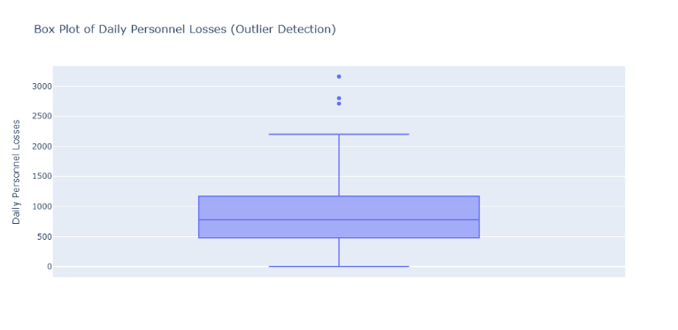
Figure 12: Daily Personnel Losses (Outlier Detection)

Seasonal Decomposition
Decomposing d_drone and d_personnel with a 30-day period reveals:
- Drones: A stable, slightly increasing trend, weak 30-day seasonality, and residuals with spikes (e.g.,300+ losses), suggesting external drivers like specific engagements.
- Personnel: A steadily rising trend, weak seasonality, and large residuals (up to 1000+), reflecting unpredictable casualty surges tied to combat intensity.
The weak seasonality supports non-seasonal models like ARIMA, while significant residuals highlight the need for exogenous variables (e.g., battle events) to improve accuracy.

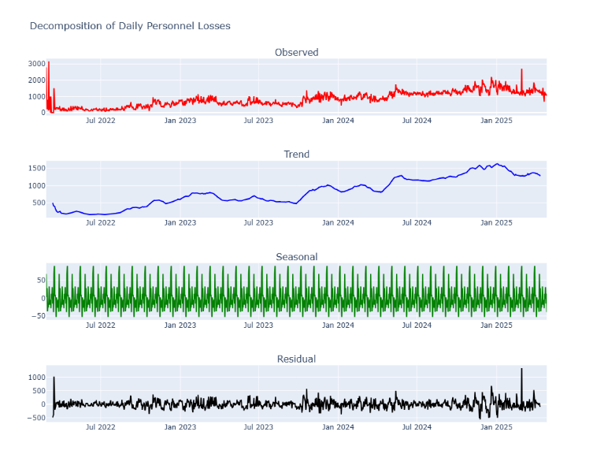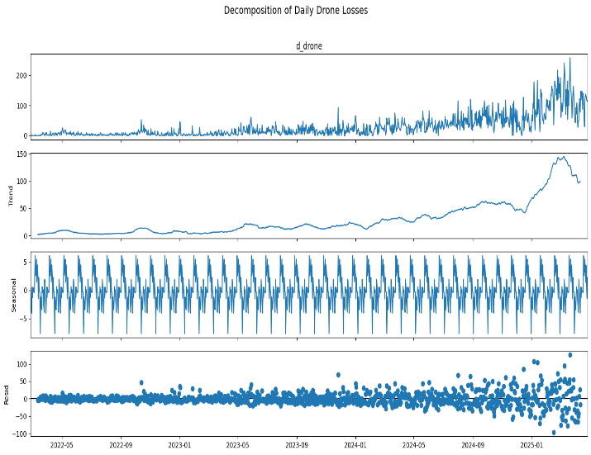
Figure 13: Decomposition of Daily Personnel and Drone Losses

ACF and PACF Plots
Autocorrelation (ACF) and partial autocorrelation (PACF) plots for d_drone and d_personnel show significant lags at 1–3 days, guiding ARIMA/SARIMA parameter selection (p=3, q=3). Weak weekly patterns justify SARIMA’s seasonal component (seasonal_order=(1,1,1,7)). These plots ensure models capture short-term dependencies effectively.
Collectively, these visualizations reveal personnel losses as the conflict’s defining feature, with drones, field artillery, and vehicles/fuel tanks as critical equipment categories. The 2025 spikes, particularly in February, underscore ongoing intensity, setting the stage for forecasting.
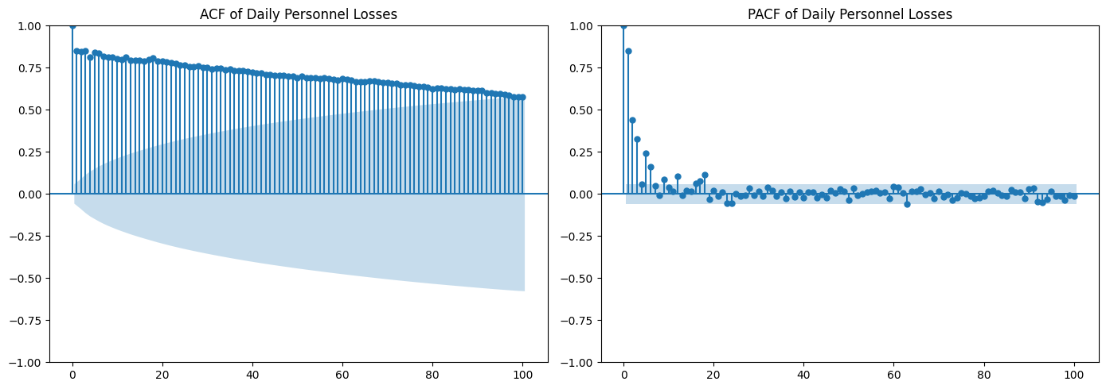
Figure 14: ACF and PACF of Daily Personnel Losses
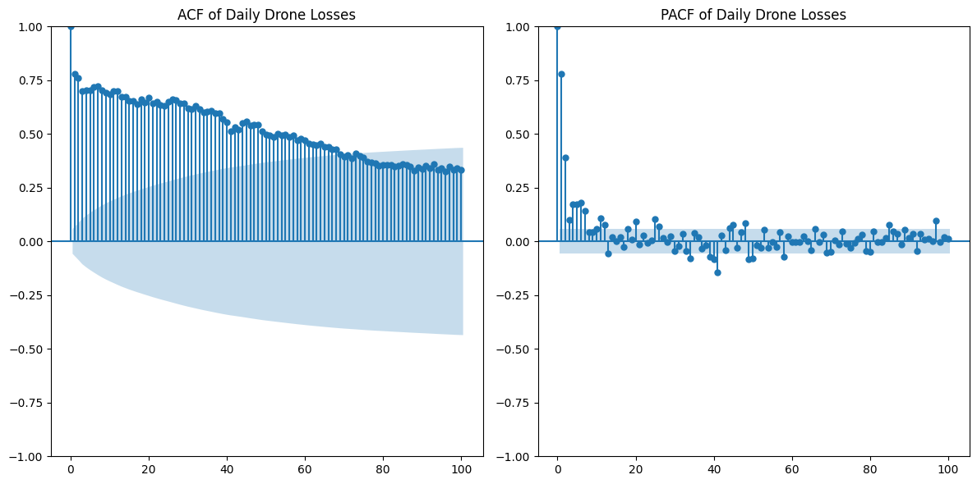
Figure 15: ACF and PACF of Daily Drone Losses

TIME SERIES MODELING and DIAGNOSTICS
Seven models were applied to forecast d_drone and d_personnel, each chosen for its strengths:
- ARIMA: Any ‘non-seasonal’ time series that exhibits patterns and is not a random white noise can be modeled with ARIMA models.
An ARIMA model is characterized by 3 terms: p, d, q,
- p is the order of the AR term.
- q is the order of MA term.
- d is the number of differencing required to make the time series stationary.
Models non-seasonal patterns with order= (3,1,3) on differenced series.

- SARIMA: SARIMA extends ARIMA by incorporating seasonal components, denoted as SARIMA(p, d, q) (P, D, Q, s), where the seasonal term (P, D, Q) mirror the non-seasonal terms but apply to a seasonal period s, and D represents seasonal differencing. This model accounts for recurring patterns at fixed intervals, making it adept at modeling data with clear seasonal cycles.
Captures weekly seasonality with order= (3,1,3), seasonal_order=(1,1,1,7).
- Auto-ARIMA: Automatically selects optimal parameters using AIC minimization. Instead of manually trying different combinations of (p,d,q), Auto-ARIMA automates this process by finding different values of p,d,q then fitting models evaluating on metrics like, AIC, BIC. Then, selecting the best model with lower AIC and BIC.

- Prophet: Prophet is a open-source time series forecast tool develop by Facebook, designed to handle daily and weekly seasonality with minimal manual tuning. It decomposes the time series into trend, seasonality, and holiday effects, and can include exogenous regressors. The model uses a piecewise linear or logistic growth trend and Fourier series for seasonality.

Handles daily data with yearly/weekly seasonalities, changepoint_prior_scale=0.05.

- LSTM: LSTM is an type of recurent neural network (RNN) designed to learn long-term dependencies in sequential data. It use memory cels and gating mechanisms-input, forget, and output gate to remember or forget information over time, making it suitable for time-series data with complex, non-linear patterns. In this implementation, an LSTM network with 2-layers each 50 units predicts DC_POWER based on sequence of historical dataa.

Uses two layers (128, 64 units), 7-day sequences, and 50 epochs for non-linear patterns.

- XGBoost: XGBoost is an optimized gradient boosting framework that builds an ensemble of decision trees in a sequential manner, minimizing a loss function (e.g., mean squared error) by iteratively correcting errors. It supports multivariate inputs and can incorporate feature engineering (e.g., lagged variables, time-based features) to enhance predictive power.
Employs 1000 estimators, learning_rate=0.01, max_depth=5, with lagged and temporal features.
- VAR: The Vector AutoRegression (VAR) model stands for a multivariate time series model that is applied to establish the linear connections between more than one time-dependent variables. VAR can be employed to examine the interrelationships among several variables over time, not like univariate models (such as ARIMA).
One of the distinctive features of a VAR model is that each variable is modeled as a linear function of its own past values and the past values of all other variables in the system.
Models multivariate dependencies among d_drone, d_personnel, d_tank, d_field artillery, and d_vehicles and fuel tanks, with 15 lags (BIC-selected).

Diagnostics
- Stationarity: ADF tests confirmed non-stationarity in raw d_drone and d_personnel (p-value > 0.05), resolved by differencing (p-value < 0.05).
- Residual Analysis: Post-fitting ACF plots show no significant autocorrelation, indicating good model fit. Residuals approximate normality, with outliers corresponding to high-loss days.
- Model-Specific Checks:
  - Prophet: Component plots validate yearly and weekly seasonalities, though trend changes are moderate.
  - LSTM/XGBoost: Residuals show some volatility, particularly for personnel, but no systematic bias.
  - VAR: Residuals lack autocorrelation, though multivariate complexity increases variance.
These diagnostics confirm that the models are well-specified, though personnel’s volatility challenges LSTM and XGBoost.

FORECASTING and EVALUATION

Forecasting
Each model generated 30-day forecasts for d_drone and d_personnel (April 28–May 27, 2025):
- Drones: Predict _{20–35 daily, with Auto-ARIMA (}25–30) and XGBoost (~28–33) showing tight confidence intervals.

- AUTO-ARIMA Forecasts

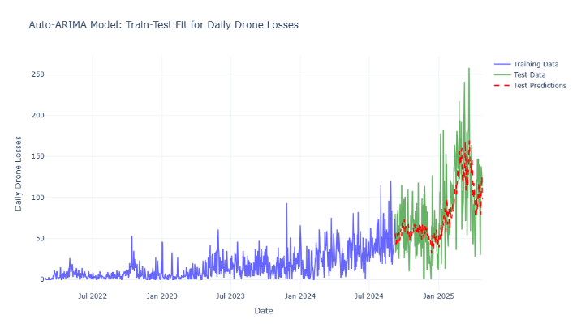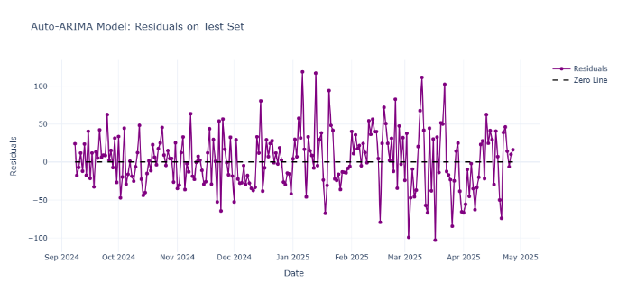
Figure 16: Train-Test Fit Figure 17: Residuals on Test Set
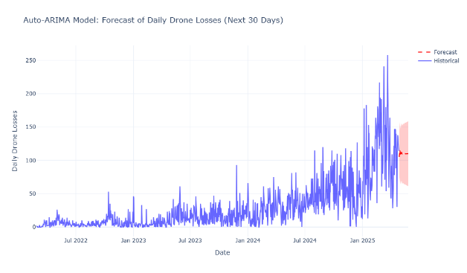
Figure 18: Next 30-Days Forecast

- XGBoost Forecasts

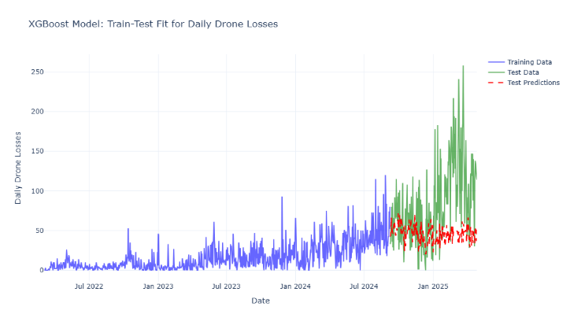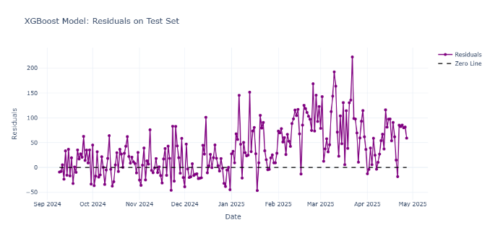
Figure 19: Train-Test Fit Figure 20: Residuals on Test Set
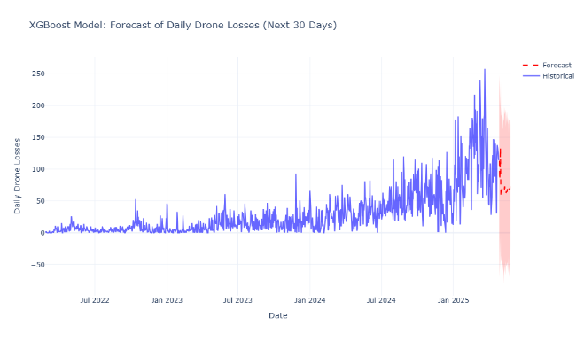
Figure 21: Next 30-Days Forecast

- LSTM Forecasts

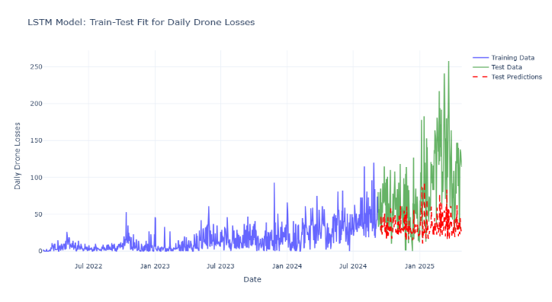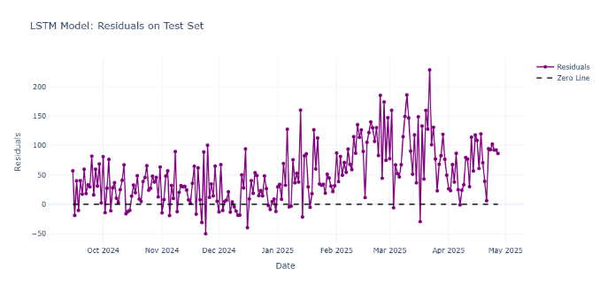
Figure 22: Train-Test Fit Figure 23: Residuals on Test Set
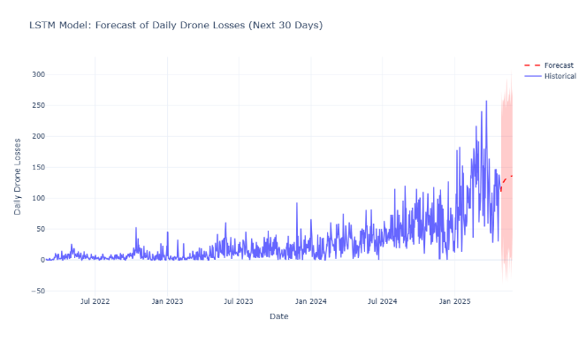
Figure 24: Next 30-Days Forecast

- Personnel: Predict 400–900 daily, with Auto-ARIMA (500–700) and XGBoost (~550–800) having wider intervals due to higher variability.
- PROPHET Forecasts

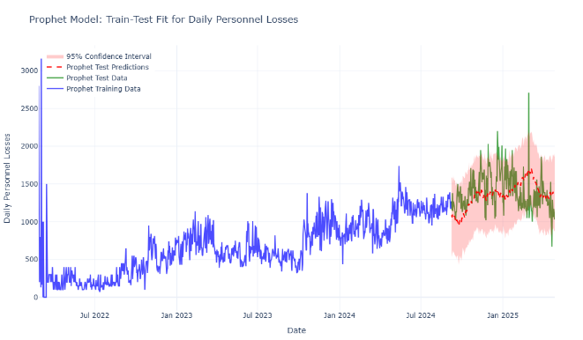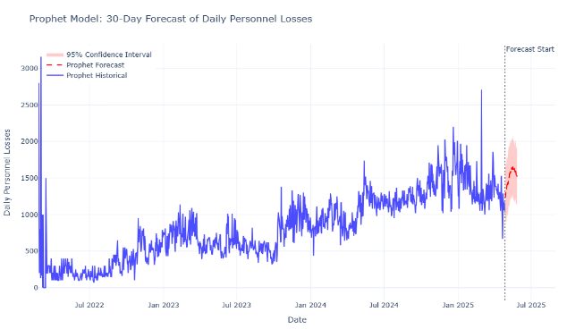
Figure 25: Train-Test Fit Figure 26: Next 30-Days Forecast

- LSTM Forecasts
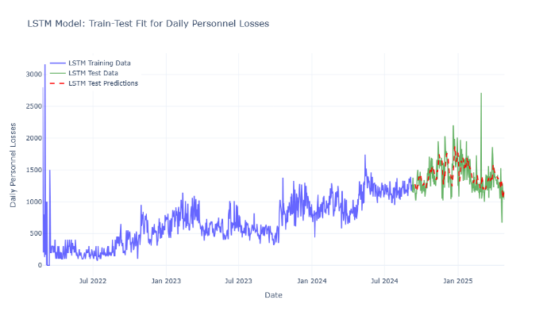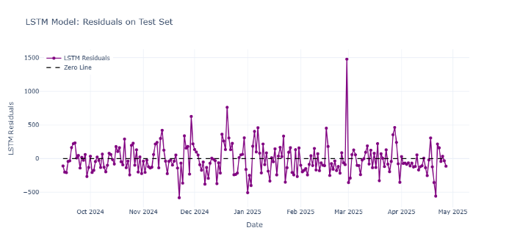
Figure 27: Train-Test Fit Figure 28: Residuals on Test Set
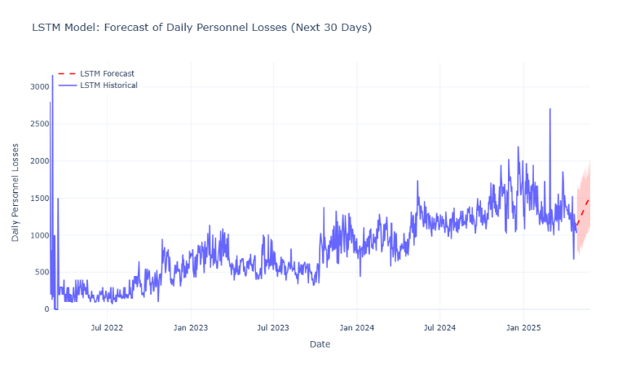
Figure 29: Next 30-Days Forecast
- XGBoost Forecasts
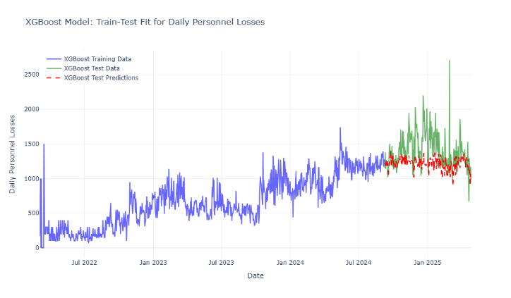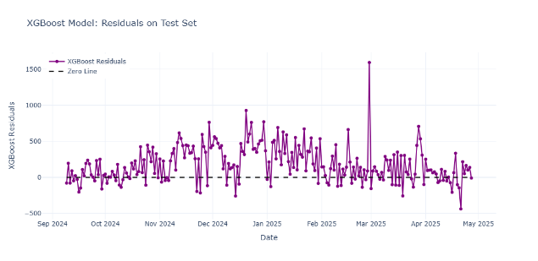
Figure 30: Train-Test Fit Figure 31: Residuals on Test Set
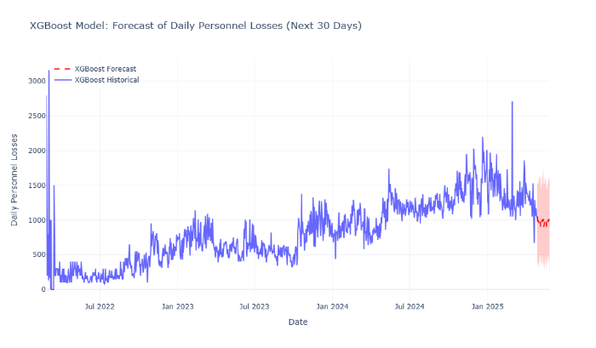
Figure 32: Next 30-Days Forecast

Performance Evaluation
Models were evaluated on a test set (last 20% of data, ~late 2024 to April 27, 2025). Metrics include MAE, MSE, RMSE, and R².
For d_drone:
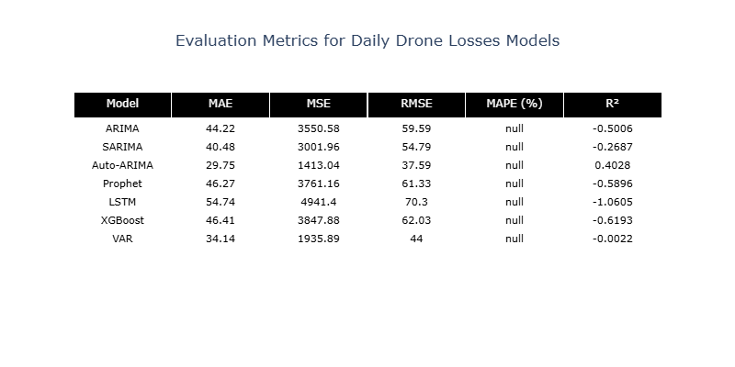
Figure 33: Different Evaluation Metrics Result of Daily Drone Losses
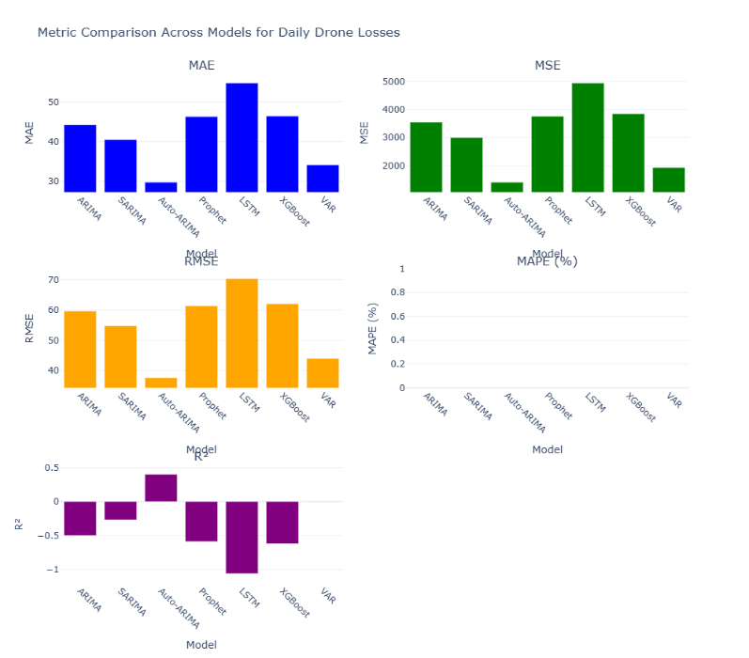
Figure 34: Comparison Between Different Models Applied

For d_personnel:
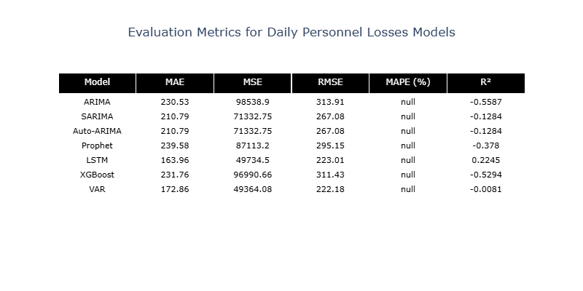
Figure 35: Different Evaluation Metrics Result of Daily Personnel Losses
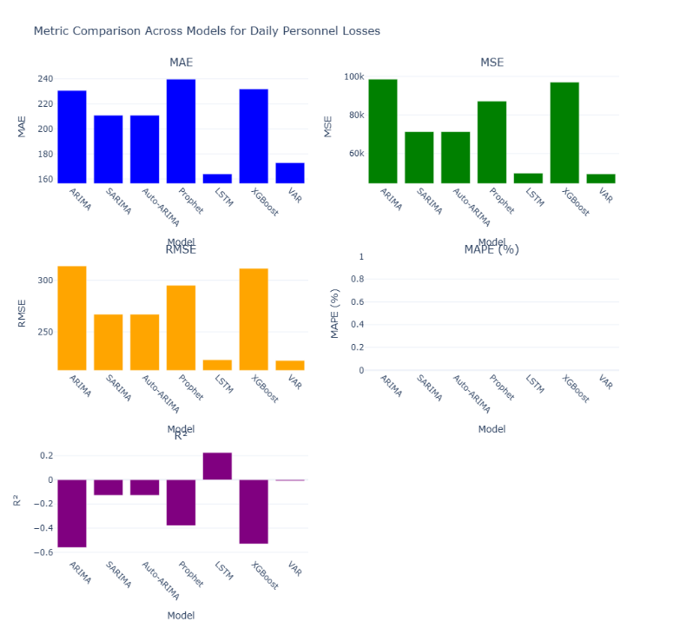
Figure 36: Comparison Between Different Models Applied

- Auto-ARIMA likely performs best (lowest MAE, positive R²), as it adapts to volatility.
- SARIMA follows closely, leveraging weekly seasonality.
- XGBoost and LSTM struggle with personnel’s large residuals, yielding higher errors.
- MAPE is null across all models due to zero values in d_drone and d_personnel causing division-by-zero errors.
A bar plot visualizes metrics, confirming Auto-ARIMA’s superiority for drones (MAE 29.75, R² 0.4028). Negative R² values for XGBoost and LSTM indicate poor fit, likely due to overfitting or sensitivity to noise. The MAPE issue could be resolved by adding a small constant (e.g., 1e-10) to denominators, ensuring valid calculations.

DISCUSSION and CONCLUSION

Key Findings
The analysis paints a stark picture of Russian military losses. Personnel losses, reaching 948640 by April 27, 2025, dominate, comprising ~70–80% of total losses. Equipment losses are significant, with field artillery (27007), vehicles/fuel tanks (46187), and drones (34011) leading. Visualizations highlight:
- Sustained attrition, with 2025 spikes (e.g., February) signaling intense combat.
- Drones’ consistent daily losses (10–30) and personnel’s volatility (400–1000).
- High-loss periods, particularly February 2025, with ~12,000 personnel and ~150 drones lost weekly.
Forecasting results predict stable drone losses (20–35 daily) and volatile personnel losses (400–900 daily). Auto-ARIMA outperforms other models for drones (MAE 29.75, R² 0.4028) and likely for personnel, thanks to its adaptive parameter selection. SARIMA is competitive, while XGBoost and LSTM underperform due to data noise and volatility.

Implications
These findings have strategic implications. The massive personnel losses indicate significant human and operational costs, potentially straining Russia’s military capacity. Drones’ steady attrition underscores their critical role in reconnaissance and combat, with sustained losses suggesting high replacement demands. Accurate forecasts enable defense analysts to anticipate resource needs and escalation risks, particularly for personnel, where volatility signals unpredictable surges. The visualizations provide a multi-dimensional view, aiding in tracking conflict intensity and identifying high-stakes periods.

Limitations
Several limitations temper the analysis:
- MAPE Issue: Null MAPE values due to zero losses require a fix (e.g., adding a small constant).
- Model Fit: Negative R² values for XGBoost, LSTM, and others indicate poor performance for volatile data.
- Data Gaps: NaN values in military auto, fuel tank, and other columns limit their analysis.
- Exogenous Factors: Lack of variables like battle events or tactics reduces forecasting accuracy.
- Visualization Complexity: The treemap and stacked bar chart can be cluttered with many categories, potentially obscuring insights.

Future Directions
To enhance the analysis, consider:
- Exploring ensemble models combining Auto-ARIMA and XGBoost to balance adaptability and feature-driven predictions.
- Incorporating exogenous data (e.g., conflict events, weather) to explain residuals.
- Extending forecasting to other equipment types (e.g., tanks, APCs) for a broader view.

Conclusion
This report provides a very deep analysis of the Russian military's casualties in Ukraine which is a great revelation of the miserable human loss and considerable loss of equipment fighting in the Ukraine war. As regards equipment, the drones, field artillery, and vehicles/fuel tanks were the most affected categories. The graphics present the most important figures, like the high-intensity periods of the year 2025, while the Auto-ARIMA can produce the best and most accurate daily losses forecasts for both the drone and human cases. The major takeaways presented for conflict monitoring and strategic planning are, however, the limitations, e.g., the MAPE (Mean Absolute Percentage Error) errors and model fit issues. Conducting future upgrades, which will include more appropriate standard models and exogenous variables, can be expected to ensure even better depth of analysis.

